NAME: HISHAM AHMAD WADOOD
REG NO: 25345
SECTION: CB
SUBJECT: SCD
SUBMITTED TO: MAAM FARYAL

LAB # 03

Task # 01
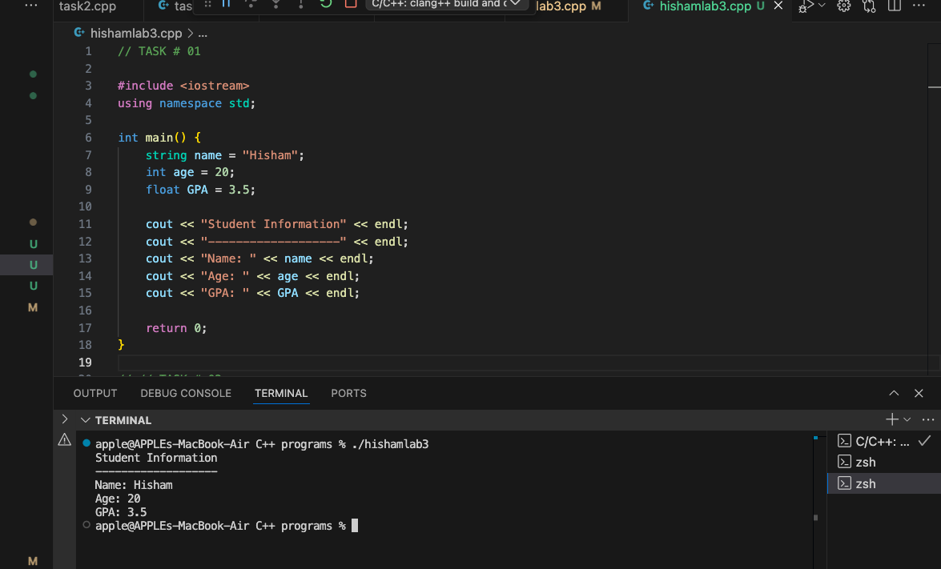

Task # 02
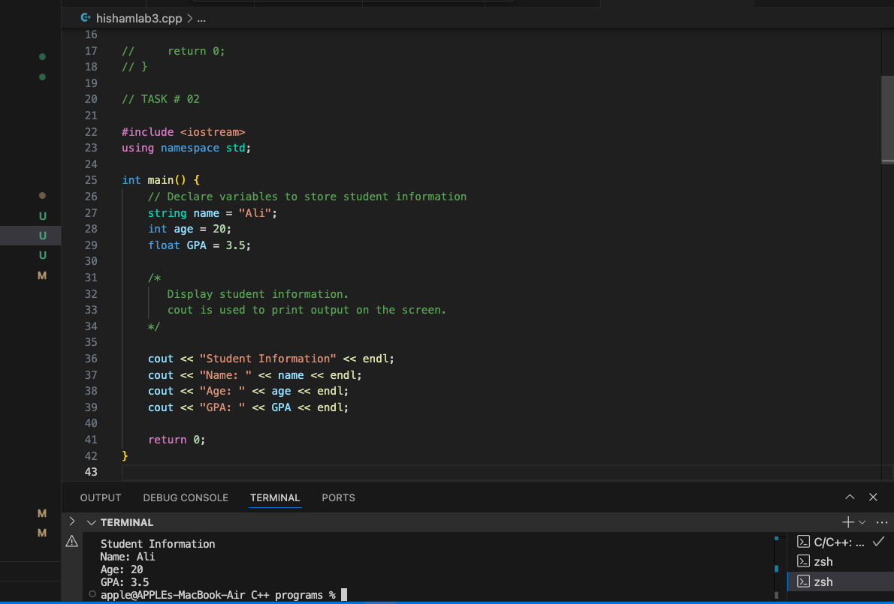
Task # 03
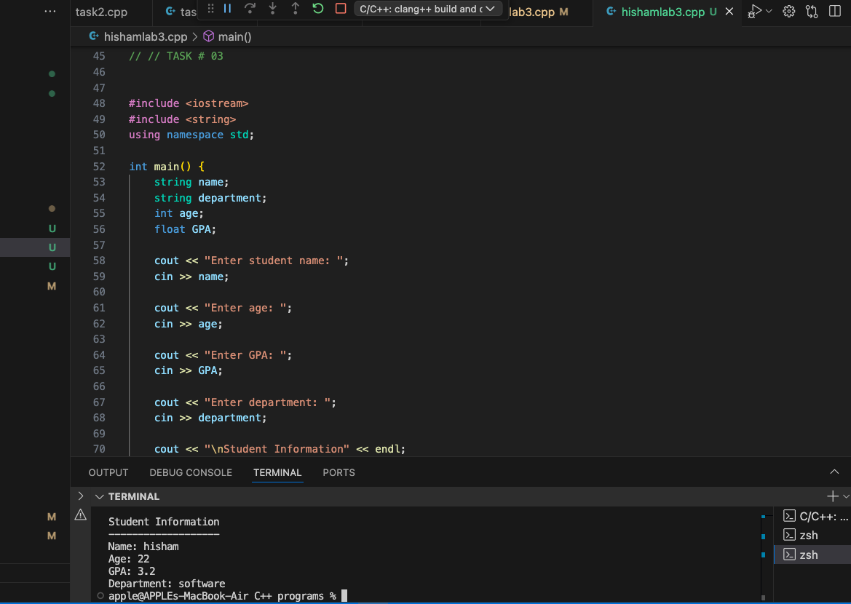
Task # 04 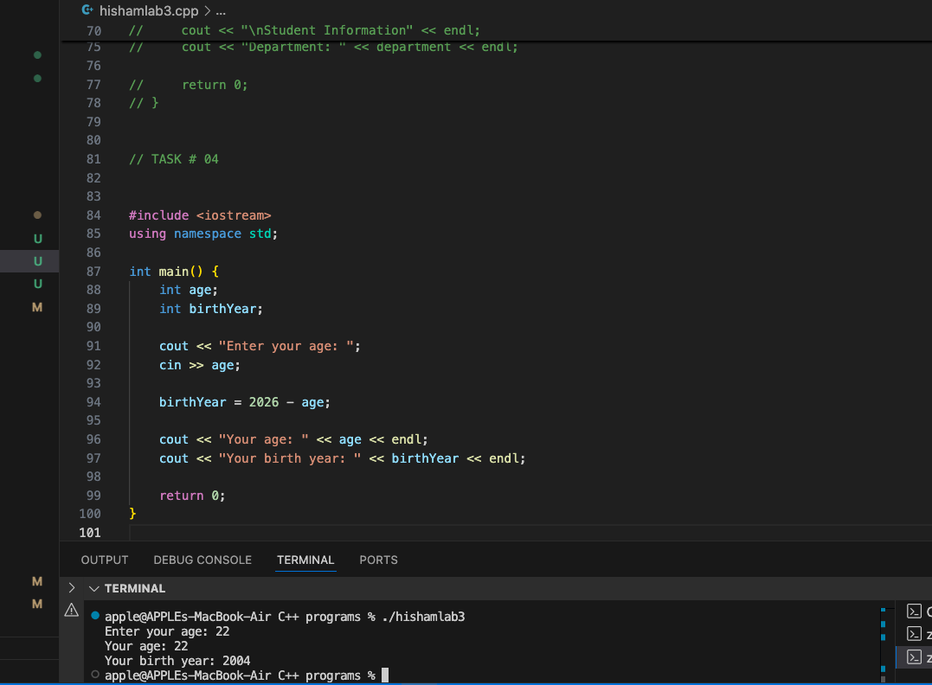

Task # 05
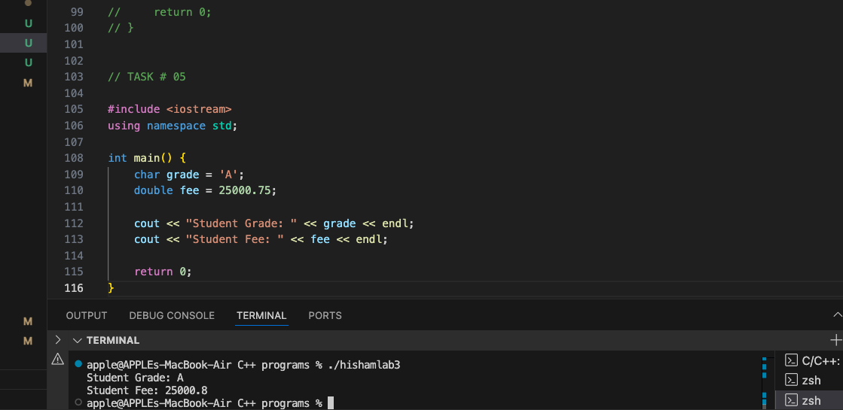

GITHUB TASK

